**Regional thermal adaptation will not prevent swelling global soil respiration rates[1]**

Jinshi Jian1*, Meredith K Steele1

*Corresponding author: Jinshi Jian ([jinshi@vt.edu)](mailto:jinshi@vt.edu))

Orcid ID: 0000-0002-5272-5367

**Between the 1960s and 2000s, global soil respiration (Rs) accelerated at a rate of 0.04 to 0.1 Pg C yr-1 1–3; however, future acceleration is uncertain because the Rs of some regions could adapt to rising temperatures (thermal adaptation) 4–6 . Here, using monthly global Rs data, we modeled Rs and temperature for the global and eight climate regions and estimated annual Rs from 1961-2014 and 2015-2100.** **We found that historical global annual Rs acceleration (0.05 Pg C yr-1) was similar to previous historical estimates; however, under a future 3ºC warming scenario, the forecasted acceleration doubled to 0.11 to 0.13 Pg C yr-1. Under this scenario, regional thermal adaptation occurred in the arid, winter-dry temperate and tropical climates; however, these adaptions were offset by large Rs acceleration in boreal and polar regions. In contrast, under a < 1ºC warming scenario the global Rs decelerated slightly from current rates. If rising global temperatures remain unmitigated, this work suggests that future acceleration of Rs will be much faster than current and historical rates, thereby enhancing future losses of soil carbon and positive feedbacks to climate change.**

Soil respiration (Rs), the production of carbon dioxide from the soil when plant roots, microbes and fauna respire, is the second largest carbon flux between the land and atmosphere1,7 . A critical factor controlling Rs is temperature 8–10, and as global temperatures rise, so are global Rs fluxes 2. From 1961 to 2011, Rs rates increased on average by 0.04 to 0.10 Pg C yr-1 1–3. While these historical trends provide some insight, the future rate of change in Rs as global temperatures rise remains uncertain, in part, because of a lack of understanding of how Rs will respond to rising temperature at different spatial scales. Though global scale Rs rates consistently increased from 1961 to 2011 1–3, numerous laboratory and warming experiments demonstrate that Rs rates declines when temperatures rise above specific optimum temperature, and at the regional scale, specific biomes are already adapting to regional temperature increases 4–6,11,12. Differences in regional scale thermal adaptation or acceleration could play an important role in future global Rs, where thermal adaption in warm regions might offset acceleration of Rs in colder regions. Understanding how these regional scale dynamics will affect global Rs rates under future temperatures enhances our ability to predict changes in regional carbon stocks and global feedbacks to carbon cycling and climate change 13.

In this study, we determined one, how the future global Rs rates will change with predicted increases temperatures, and two, if the thermal adaptation of Rs in some regions will offset acceleration in other regions enough to dampen future global fluxes. We compiled a global database of monthly-timescale Rs measurements (MGRsD, Figure S1) that included a broader range of extremes than annual-timescale databases used in previous studies 2,3. To make our estimates comparable to past studies of Rs trends, we modeled the relationships between Rs and air temperature (Ta) for both the global scale, and separately for eight climate regions, using linear, 1st order exponential, and 2nd order exponential models. We observed a distinct relationship between Rs and air temperature in each climate type (Figure S3). In warmer regions, the 2nd order models best fit Rs ~ temperature relationships, while a 1st order model best fit the polar and boreal regions (Figure S3, Table S1). Using both a single global model and aggregated regional climate models, we predicted historical global and regional scale Rs from 1961 to 2014 and future Rs from 2015 to 2100. For the future Rs estimates, we used climate data from two different warming scenarios from the Geophysical Fluid Dynamics Laboratory ESM2G model (GFDL-ESM2G) (<https://www.gfdl.noaa.gov/earth-system-model/>) (Figure S2). The one was temperature predictions for unmitigated human CO2 production (the 8.5 W/m2 Representative Concentration Pathways scenario, RCP8.5); however, the second scenario represents temperatures assuming substantial mitigation of human CO2 production (the 2.6 W/m2 Representative Concentration Pathways scenario, RCP2.6).

We found that future global Rs rates will accelerate substantially if human CO2 emissions are not mitigated and global temperatures increase by 3ºC by 2100. Historical acceleration rates were consistent with prior estimates of historical global Rs acceleration (0.04 to 0.10 Pg C yr-1) 1–3 and similar among model types (Figure 1a). Global Rs acceleration fluctuated across the decades, where Rs was relatively constant from 1961 to 1980, then increased rapidly at a rate of around 0.06 Pg C yr-1 from 1981 to 2000, and then decelerated to 0.025 Pg C yr-1 from 2001 to 2014 (Figure 1a). The damping of global Rs increases from 2001 to 2014 was likely caused by decadal fluctuations of global air temperature rather than global scale thermal adaptation. Rs rates were still positively correlated with air temperature anomalies (Figure 2), and the future global Rs rates did not show any sign of thermal adaptation from 2015 to 2100. In contrast, if no mitigation of human emissions occurs, the future global Rs rates between 2011 and 2100 the global Rs increased at an even higher rate, 0.11 and 0.13 Pg C year-1 based on the single and climate-specific models respectively (Figure 1b). Under these conditions, global Rs will increase from ~72.55 to 88 Pg C yr-1. If, however, significant reductions in emissions limit the increase in global temperatures to < 1ºC, global Rs should decline at a rate of -0.01 Pg C yr-1 by 2100 (Figure 1b).

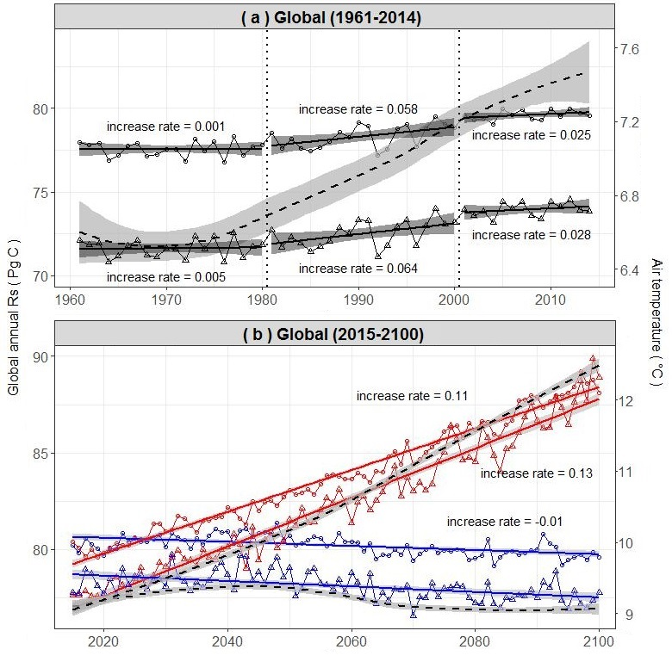

**Figure 1.** **Estimated annual global Rs.** ( a ) Estimated annual global Rs changes from 1961 to 2014, ( b ) Estimated annual global Rs changes from 2015 to 2100 under substantial mitigation of human CO2 production global warming scenario (RCP2.6, blue lines) and under unmitigated human CO2 production (RCP8.5, red lines) in global. Circles are global annual Rs estimated by single model and triangles are global annual Rs estimates by multiple models, dashed line with confidence interval range are air temperature change trend fitted by ‘loess’ method in R.

Though the global scale future Rs rates accelerated with no CO2 mitigation, some regions showed clear thermal adaptation to rising temperatures. To test for thermal adaptation, we analyzed how the Rs anomalies correlated with temperature anomalies for three scenarios: historically from 1961 to 2014 and both future (2015 to 2100) temperature scenarios (RCP2.6 and RCP8.5). Positive correlations indicated increases in Rs with temperature (no adaption), whereas null or negative correlations indicated that Rs does not respond or decreases with temperature (adaptation). From 1961 to 2014, only the temperate regions with dry summers showed thermal adaption, consistent with the previous observation of regional adaptation (Figure 2)1. Likewise, if human CO2 emissions are mitigated and warming is limited to < 1ºC, regional adaptation will be limited to temperate summer-dry regions (Figure 2). However, when global temperatures increased by 3 ºC, the climate-specific models predicted thermal adaptation in the arid, winter-dry and summer-dry temperate, and tropical climates (Figure 2). In contrast, the single global model did not predict thermal adaptation in any region (Figure 2). This contradiction between the single and climate-specific models was likely caused by regional heterogeneity in the optimum temperature for Rs and thermal adaptation. For example, in the temperate summer-dry climate, the climate-specific models estimated a temperature threshold of 14.39 °C, but the single model estimated of threshold of 27.50 °C across the globe (Table S1). Therefore, when temperature was over 14.39 °C, the climate-specific models predicted declines in Rs, whereas the single model still predicted positive response in temperate summer dry region. This variation between predictions from single and multiple models highlights the need to account for regional heterogeneity in the response of Rs to temperature when studying the effects of warming on soil-carbon dynamics in future.

Though we observed that large regions adapted to future temperature increases, the climate-specific models predicted Rs was more sensitive to temperature increases in colder regions (Figure 2) and increased Rs in the boreal and polar regions dominated the future global Rs rates (Figure S5). The predicted increase in Rs in the boreal and polar regions may have substantial effects on losses of carbon stocks in those regions. The temperature of colder regions is increasing at higher rate compared to the rest of the globe and almost 1,700 Pg of organic C is stored in the permafrost 16. A recent meta-analysis that compared total percentage soil carbon under warming and ambient conditions across Eurasia and North America, and found warming stimulated carbon losses from soil to the atmosphere regardless of how many years (effect-time) the full soil carbon response to warming is realized, but with a very large range of uncertainty 17. Given the larger acceleration rates and no apparent thermal adaptation observed in this study, the loss of soil carbon stocks may be towards the upper end (~ 200 Pg C) of the uncertainty bounds if human emissions are not limited 17, mainly driven by carbon losses in colder climates. An increase in primary production carbon may offset losses from soil respiration; however, substantial uncertainty still exists in the response of primary productivity to CO2 fertilization18–20 and global warming induced drought21 at regional and global scales.

We found that global annual mean Rs during the historical period (1961 to 2014) estimated from the single model (mean with 95% confidence interval: 78.34±4.40) did not significantly differ from the region-specific estimate (72.55±13.97 Pg C yr-1). These estimates are consistent with previous estimates based on monthly Rs data14,15, but lower than previous estimates based on annual Rs data1–3. In contrast, regional-scale estimates derived from the single global modal differed substantially from estimates derived from aggregated region-specific models. This difference in Rs estimates ranged from -2.14 to 9.67 Pg C yr-1 (Table 1). The single model overestimated Rs rates in arid regions, which led to a cumulative difference of 9.67 Pg, approximately 55% of the annual flux from arid regions. In contrast, the single model underestimated Rs 39.8% in polar region. When compared to observed Rs, the single model tended to overestimate Rs in arid regions but underestimate Rs in cold regions, whereas the climate-specific models more accurately estimated the regional Rs response to temperature change (Figure S4). In tropical, temperate, and boreal regions, the difference between single model and climate-specific models were relatively small (Table 1). Arid and boreal regions make up a large proportion of global land area (17.8% and 37.67%, respectively), but also had a more limited number of Rs measurements relative to other regions (Figure S1). The lack of data in arid and polar regions contributes some uncertainty and more measurements from these regions would be valuable to global Rs estimates (Table 1).

Regional heterogeneity in relationship between Rs and air temperature influenced how Rs will respond to future warming temperatures. Climate-specific models could improve the accuracy of global Rs models and help constrain predictions of changing soil carbon stock across regions in response to climate change. This study provides further evidence that thermal adaptation could occur at large spatial scales; unfortunately, this thermal adaption will likely not be strong enough to suppress the surge in soil respiration rates if global temperatures are allowed to rise by 3ºC. The acceleration of Rs rate in boreal and polar regions will likely mask the deceleration of Rs in warmer climates.

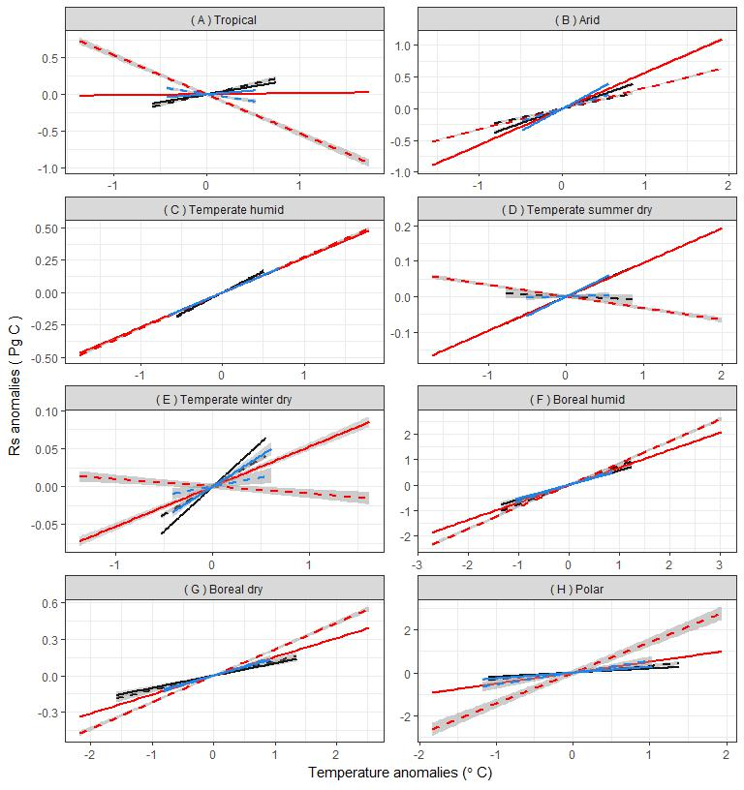

**Figure 2.** **Relationship between soil respiration anomalies and temperature anomalies.** Estimated annual soil respiration (Rs) anomalies and response to temperature anomalies from 1961 to 2014 (black lines), 2015 to 2100 under substantial mitigation of human CO2 production scenario (RCP2.6, blue lines), and from 2015 to 2100 under unmitigated human CO2 production scenario (RCP8.5, red lines). Solid lines represent results from the single model, while dashed lines are results from climate climate-specific models. From 1961 to 2014 and from 2015 to 2100 under RCP2.6, the Rs response to warming showed no thermal adaptation (Rs anomalies responds positively to temperature anomalies) for both single and climate-specific models except temperate summer dry. From 2015 to 2100 under RCP8.5, Rs thermal adaptation occurred in tropical, temperate summer-dry and temperate winter-dry climates, but this thermal adaptation was only detected by climate-specific models. In Boreal and polar climates, however, Rs responds to warming even more sensitive in future under RCP8.5 than in the historical period.

**Table 1**. **Area extent and estimated mean annual soil respiration rate (Rs) of globe for 8 climate regions classified by Koeppen_Geiger classification.** Tropical (A), Arid (B), Temperate humid (Cf), Temperate summer dry (Cs), Temperate winter dry (Cw), Boreal humid (Df), Boreal summer dry or winter dry (Dsw) and Polar (E). Grid cells were 0.5 ° latitude × 0.5 ° longitude; each cell area was calculated as 0.173905 × 104 km2. The mean Rs was weighted by region area and was averaged for each vegetation coverage from 1961 to 2014.

|  |  |  |  |  |  |  |  |  |  |
| --- | --- | --- | --- | --- | --- | --- | --- | --- | --- |
| Climate Region | Number of grid cells | Area  (104 km2) | Single model | | Climate-specific models | | |  | |
| Mean Rs rate (g C m-2 day-1) | Annual mean Rs  (Pg C yr-1) | | Mean Rs rate (g C m-2 day-1) | Annual mean Rs  (Pg C yr-1) | | Difference (Single model–Specific) |
| A | 9746 (11.36%) | 1695 | 3.47 | 21.45 | | 3.73 | 23.11 | | -1.66 (-7.2%) |
| B | 15273 (17.80%) | 2656 | 2.82 | 27.31 | | 1.82 | 17.64 | | +9.67 (+54.8%) |
| Cf | 4868 (5.67%) | 847 | 2.36 | 7.29 | | 2.25 | 6.97 | | +0.32 (+4.6%) |
| Cs | 1590 (1.85%) | 276 | 2.35 | 2.37 | | 1.96 | 1.98 | | +0.39 (+19.7%) |
| Cw | 2046 (2.38%) | 356 | 2.86 | 3.71 | | 2.09 | 2.71 | | +1.00 (+36.9%) |
| Df | 17047 (19.87%) | 2964 | 1.06 | 11.49 | | 1.26 | 13.63 | | -2.14 (-15.7%) |
| Dsw | 2902 (3.38%) | 505 | 1.21 | 2.22 | | 1.28 | 2.36 | | -0.14 (-5.9%) |
| E | 32322 (37.67%) | 5621 | 0.12 | 2.50 | | 0.20 | 4.15 | | -1.65 (-39.8%) |
| Global | 85794 | 14920 | 1.44 (weighted) | 78.34 (±4.4) | | 1.33 (weighted) | 72.55 (±13.97) | | +5.79 (+8.0%) |

Methods

We created a global monthly soil respiration database to support single and climate region specific Rs modeling. Historical (1961 to 2014) and future (2015 to 2100) air temperature data were collected from the Center for Climate Research at the University of Delaware (0.5° longitude × 0.5° latitude) and from the Geophysical Fluid Dynamics Laboratory (GFDL-ESM2G ) model (2.5 ° longitude × 2.0° latitude), and applied to the single and climate-specific models to estimate global annual Rs from 1961 to 2100. Rs responds to air temperature for historical period (1961 to 2014), under global warming scenario RCP2.6 between 2015 and 2100, and under global warming scenario RCP8.5 between 2015 and 2100 within eight climate regions were analyzed to identify the Rs thermal adaptation and how it affect Rs responds to future global warming. Parameterization of global single Rs model and climate-specific models were conducted using the maximum likelihood estimation approach in R 22. All data used for this study can be found at <https://data.lib.vt.edu/collections/ns0646000>. Supplementary materials contain detailed explanation of the method and analysis.

References

1. Zhao, Z. *et al.* Model prediction of biome-specific global soil respiration from 1960 to 2012. *Earth’s Futur.* **5,** 715-729, (2017).

2. Bond-Lamberty, B. & Thomson, A. Temperature-associated increases in the global soil respiration record. *Nature* **464,** 579–82 (2010).

3. Hashimoto, S. *et al.* Global spatiotemporal distribution of soil respiration modeled using a global database. *Biogeosciences Discuss.* **12,** 4331–4364 (2015).

4. Bradford, M. A. *et al.* Thermal adaptation of soil microbial respiration to elevated temperature. *Ecol. Lett.* **11,** 1316–1327 (2008).

5. Crowther, T. W. & Bradford, M. A. Thermal acclimation in widespread heterotrophic soil microbes. *Ecol. Lett.* **16,** 469–77 (2013).

6. Frey, S. D., Lee, J., Melillo, J. M. & Six, J. The temperature response of soil microbial efficiency and its feedback to climate. *Nat. Clim. Chang.* **3,** 395–398 (2013).

7. Raich, J. W. & Schlesinger, W. H. The global carbon dioxide flux in soil respiration and its relationship to vegetation and climate. *Tellus* **44 B,** 81–99 (1992).

8. Janssens, I. A. *et al.* Productivity overshadows temperature in determining soil and ecosystem respiration across European forests. *Glob. Chang. Biol.* **7,** 269–278 (2001).

9. Trumbore, S. Carbon respired by terrestrial ecosystems–recent progress and challenges. *Glob. Chang. Biol.* **2,** 141–153 (2006).

10. Davidson, E. A. & Janssens, I. A. Temperature sensitivity of soil carbon decomposition and feedbacks to climate change. *Nature* **440,** 165–173 (2006).

11. Luo, Y., Wan, S., Hui, D. & Wallace, L. L. Acclimatization of soil respiration to warming in a tall grass prairie. *Nature* **413,** 622–625 (2001).

12. Sistla, S. a *et al.* Long-term warming restructures Arctic tundra without changing net soil carbon storage. *Nature* **497,** 615–8 (2013).

13. Wieder, W. R., Bonan, G. B. & Allison, S. D. Global soil carbon projections are improved by modelling microbial processes. *Nat. Clim. Chang.* **3,** 909–912 (2013).

14. Raich, J. W. & Potter, C. S. Global patterns of carbon dioxide emissions from soils. *Global Biogeochem. Cycles* **9,** 23–36 (1995).

15. Raich, J. W., Potter, C. S. & Bhagawati, D. Interannual variability in global soil respiration, 1980–94. *Glob. Chang. Biol.* **8,** 800–812 (2002).

16. Tarnocai, C. *et al.* Soil organic carbon pools in the northern circumpolar permafrost region. *Global Biogeochem. Cycles* **23,** 1–11 (2009).

17. Crowther, T. *et al.* Quantifying global soil C losses in response to warming. *Nature* (2016). doi:10.1038/nature20150

18. Norby, R. J., Warren, J. M., Iversen, C. M., Medlyn, B. E. & McMurtrie, R. E. CO2 enhancement of forest productivity constrained by limited nitrogen availability. *Proc. Natl. Acad. Sci. U. S. A.* **107,** 19368–73 (2010).

19. Norby, R. J. *et al.* Forest response to elevated CO2 is conserved across a broad range of productivity. *Proc. Natl. Acad. Sci.* **102,** 18052–18056 (2005).

20. Korner, C. *et al.* Carbon flux and growth in mature deciduous forest trees exposed to elevated CO2. *Science.* **309,** 1360–1362 (2005).

21. Zhao, M. & Running, S. W. Drought-Induced Reduction in Global Terrestrial Net Primary Production from 2000 Through 2009. *Science.* **329,** 940–943 (2010).

22. R, C. T. *R: A language and environment for statistical computing. R Foundation for Statistical Computing, Vienna, Austria. 2013*. (2014).

Acknowledgments

This study was supported by Hatch Grant #160060.

1. Department of Crop and Soil Environmental Sciences, Virginia Tech, Blacksburg, Virginia, USA